User Manual

For

www.suzanymobiles.com

Table of Contents

How to place an order 4

How to sign in to the customer portal 9

How to sign in to the employee portal 9

How to manage records in the employee portal 10

How to create a backup 12

How to restore backup 13

# How to place an order

Step 1 – Select an item

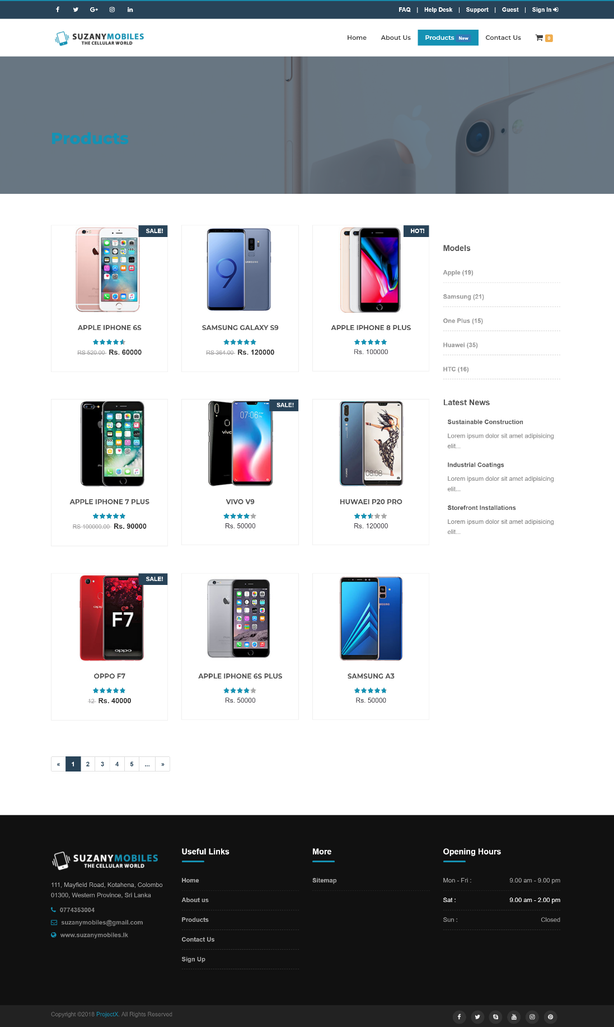

Step 2 – Select quantity and click on the “Add to cart”button

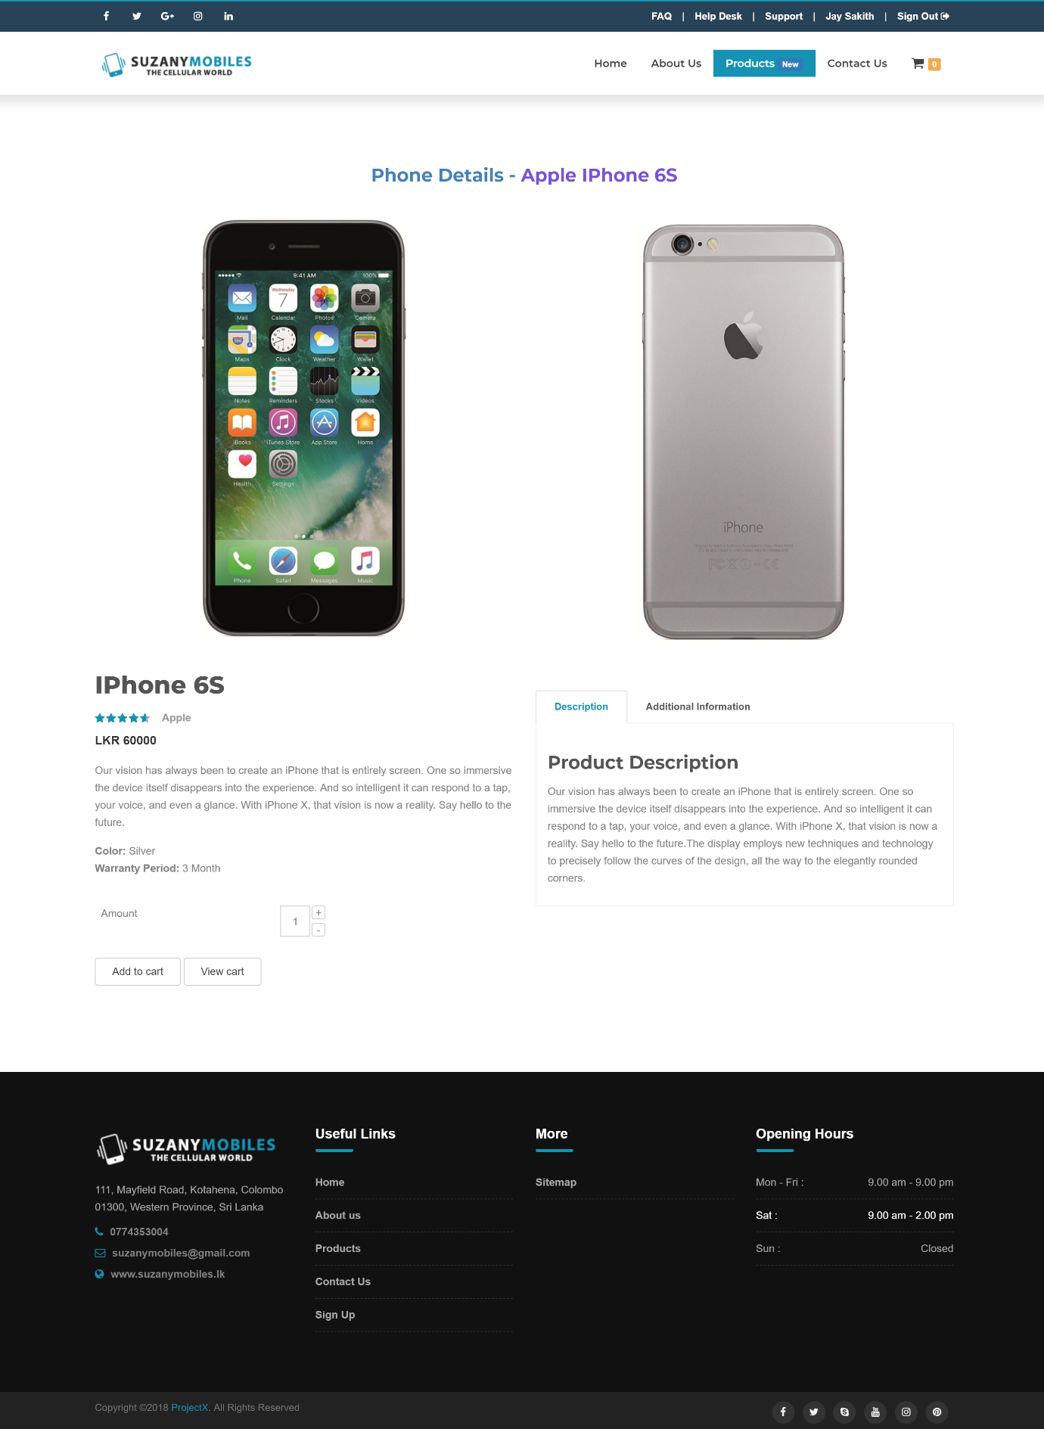

Step 3 – View the added items to the cart

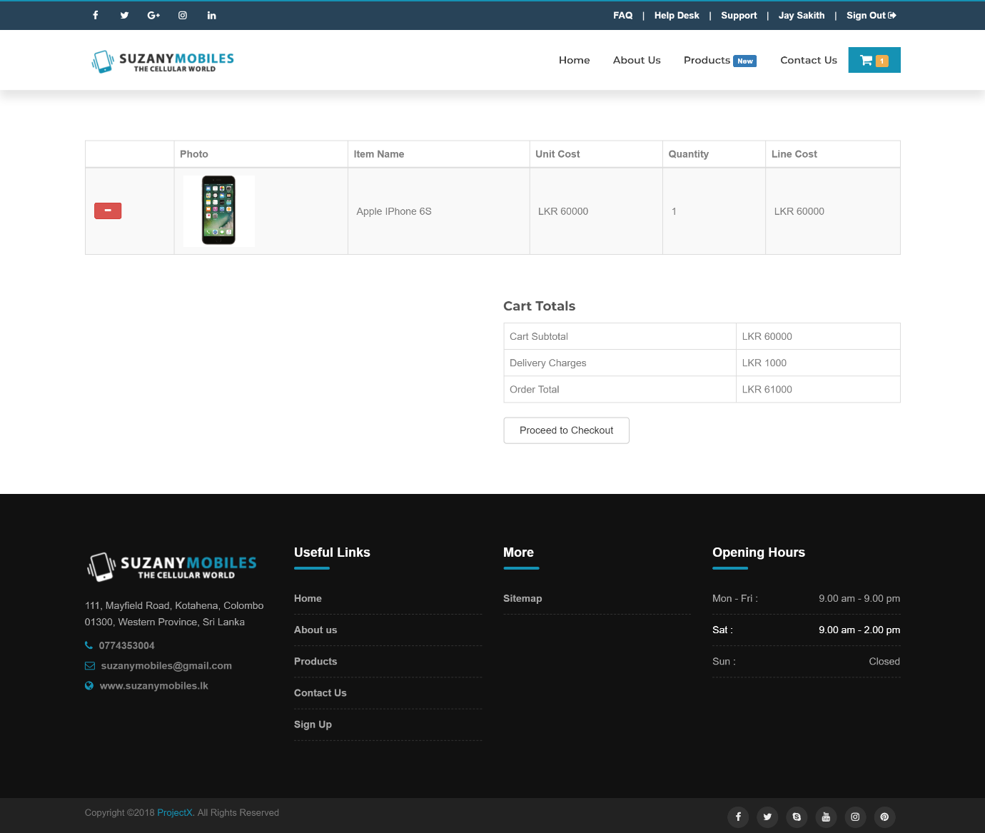

Step 3 – Final preview of the items added to the cart

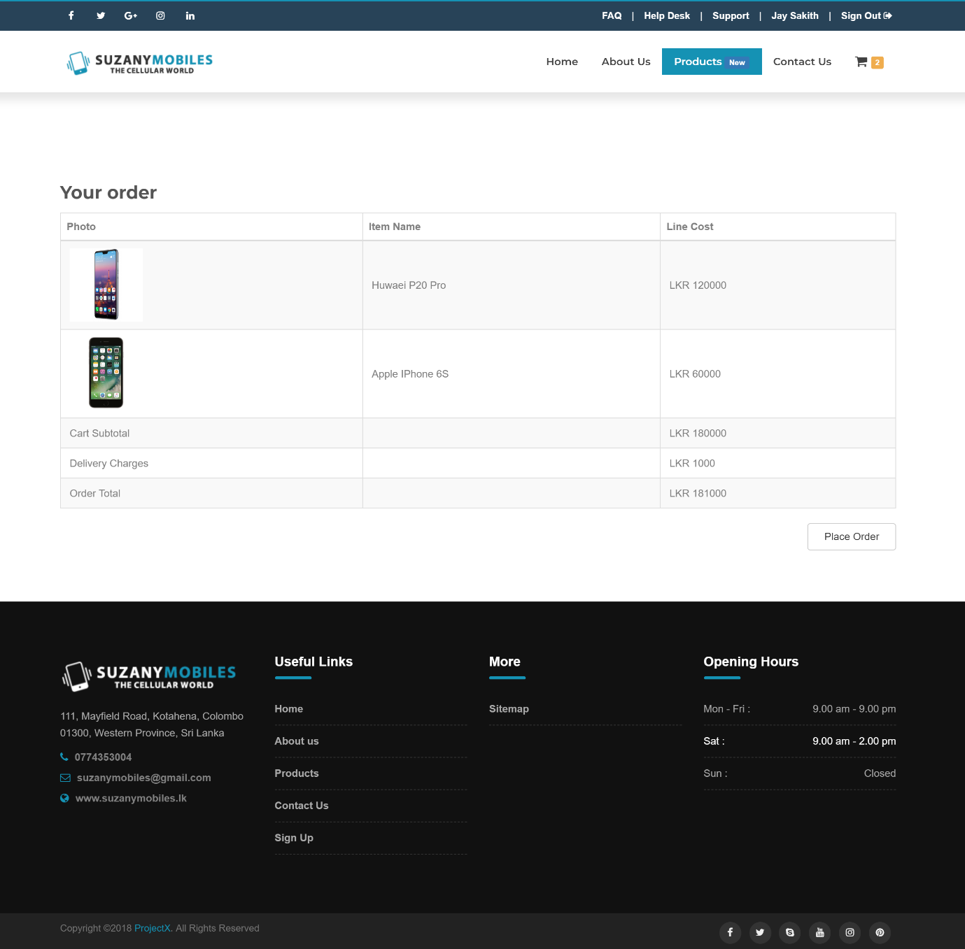

Step 4 – Final confirmation message will appear

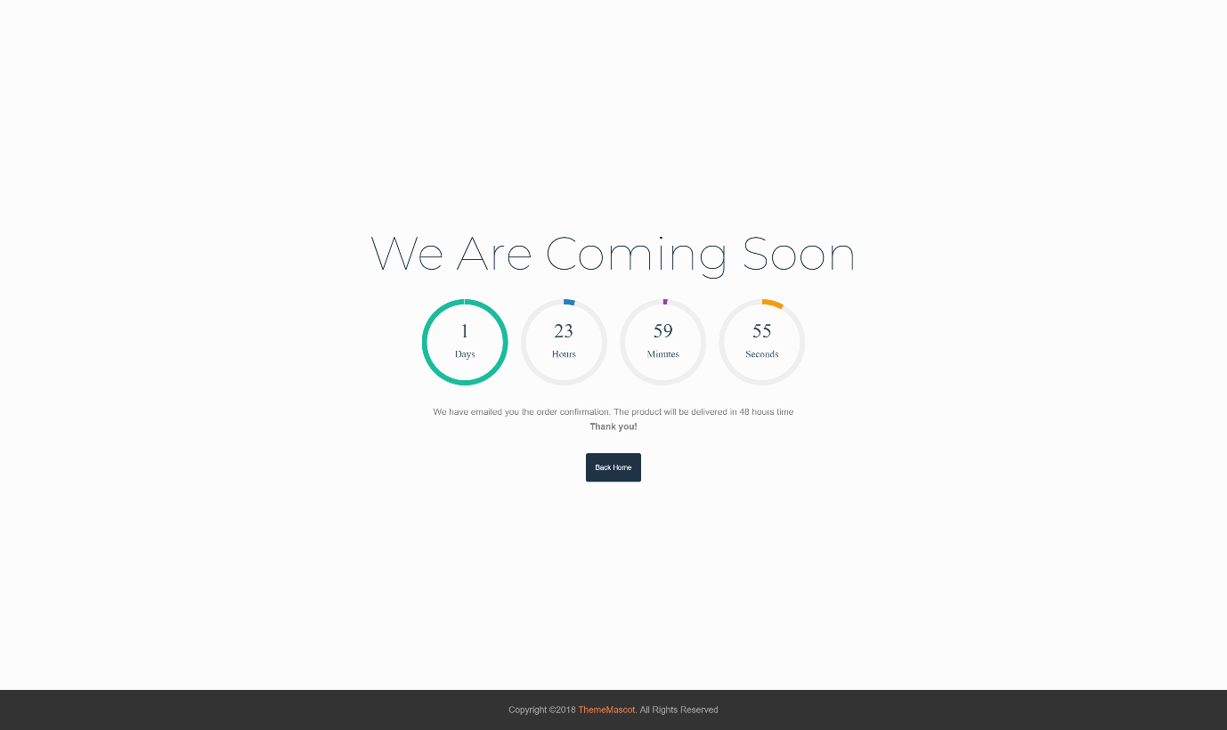

# How to sign in to the customer portal

Step 1 – Login using the given customer credentials and click on the “Login” button

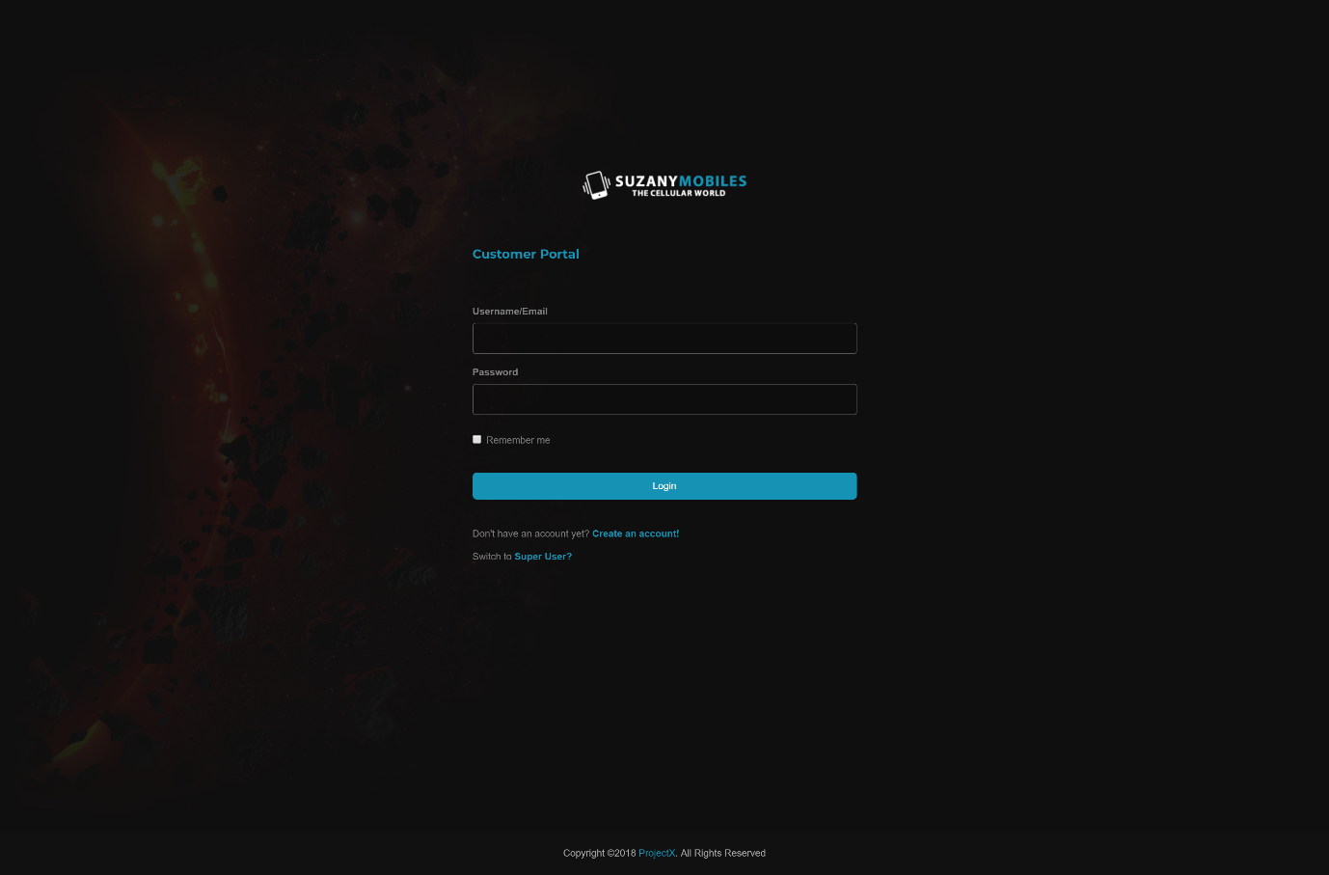

# How to sign in to the employee portal

Step 1 – Login using the given employee credentials and click on the “Login” button



# How to manage records in the employee portal

Step 1 – Select a data table in the master dropdown e.g. Supplier and click on the “Create New Record” button to add new record

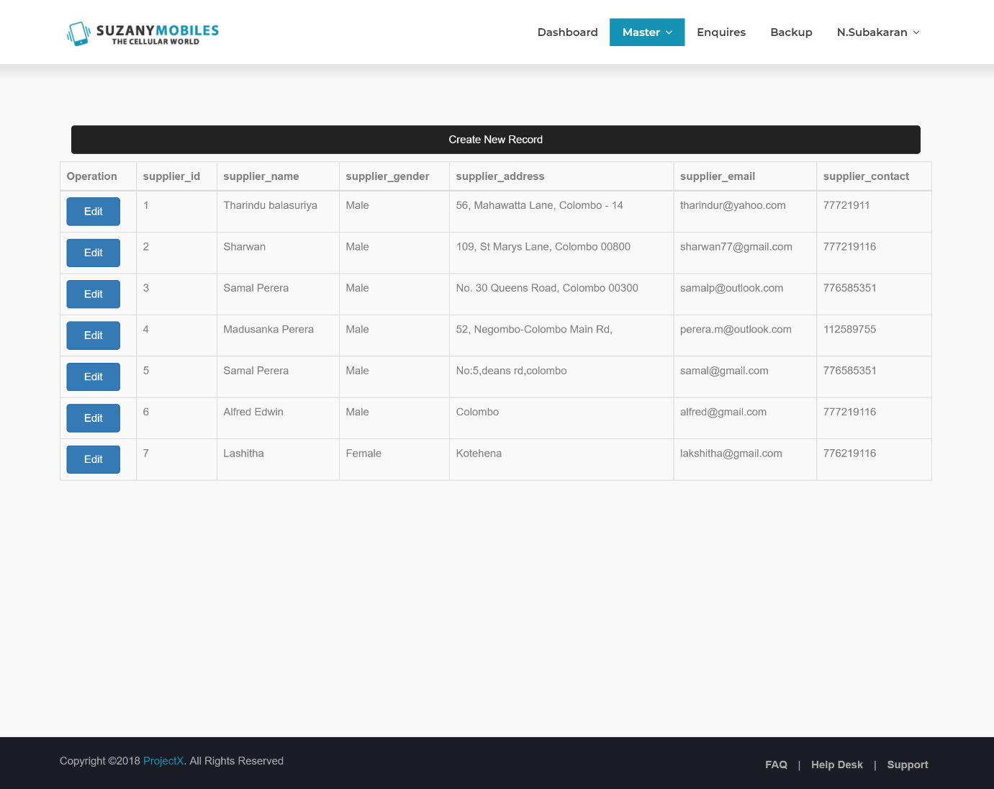

Step 2 – Fill needed fields and click on the “Save” button to create a new record

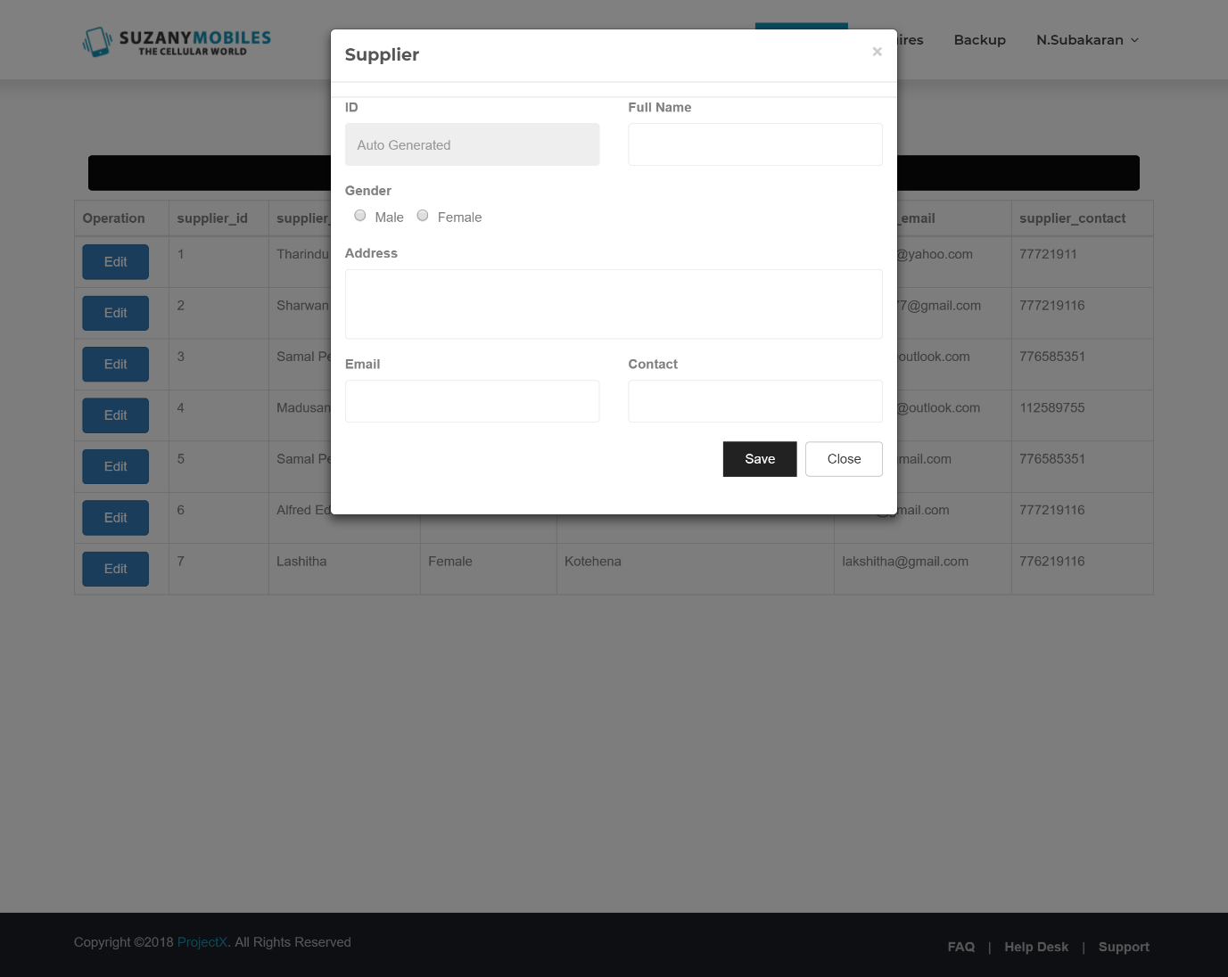

Step 3 – Click on the “Edit” button to edit a record



Step 4 – Make the necessary changes and click the “Update” button to update a record

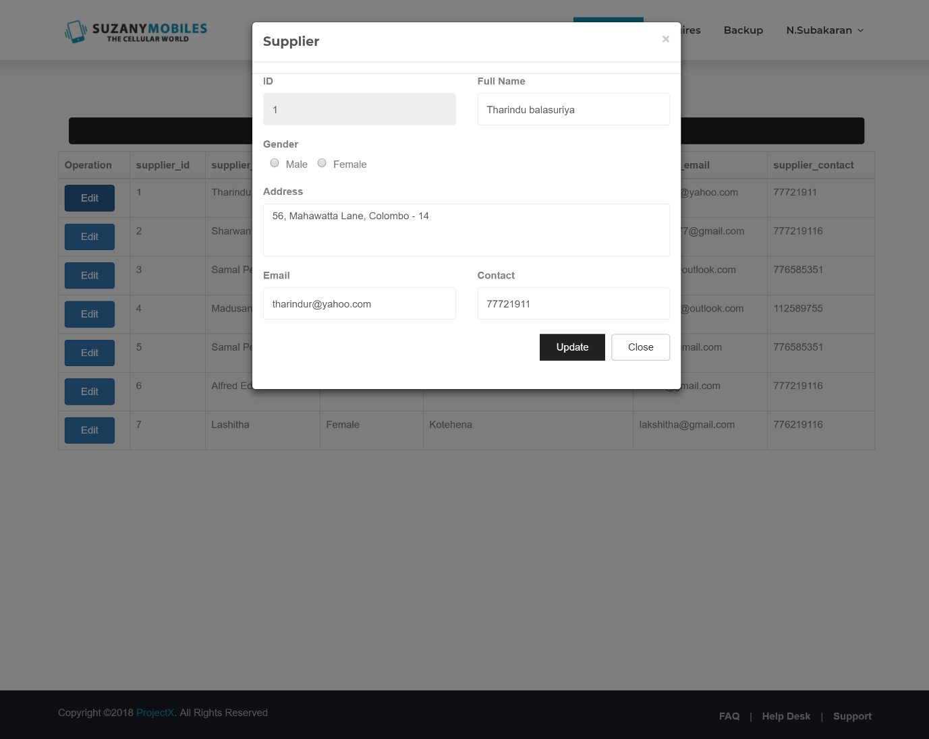

# How to create a backup

Step 1 – Click on the “Backup” button

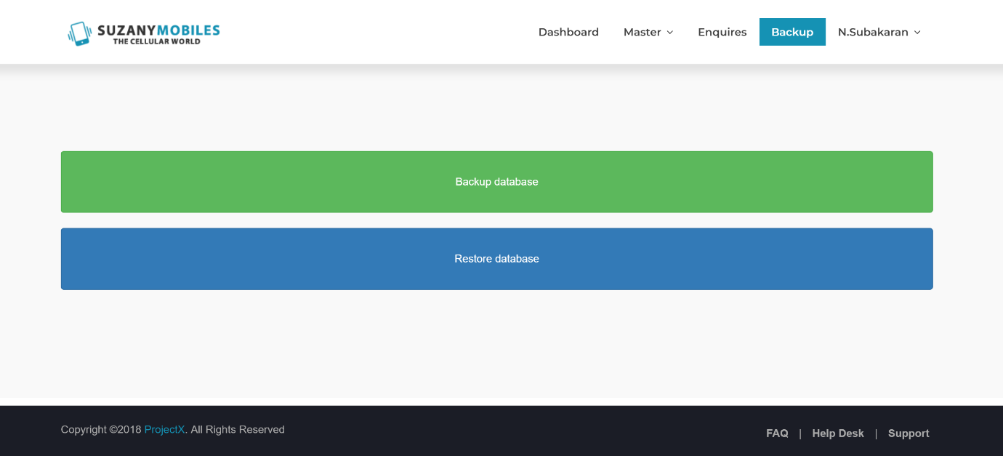

Step 2 – Select on the “Backup Database” option to backup or “Download Database” option to download backup and click on the “Backup Database” button

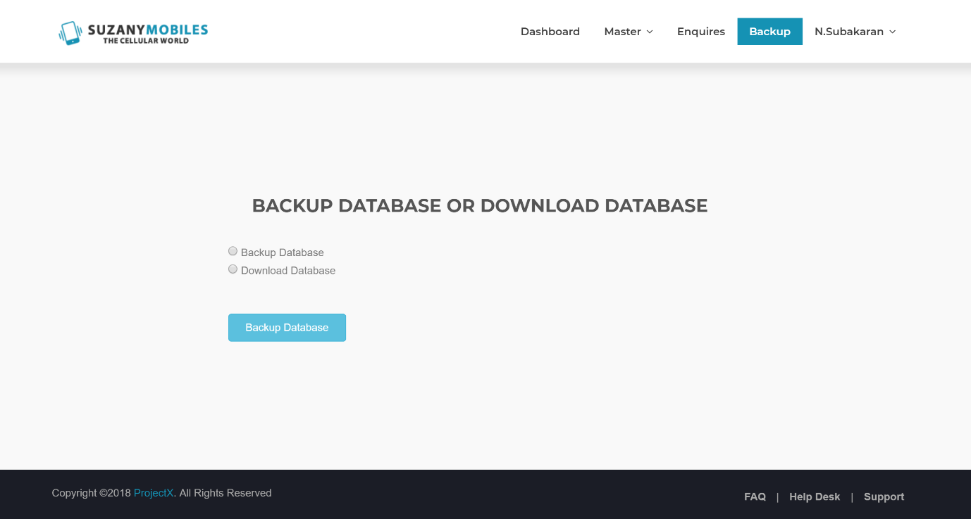

Step 3 – Prompt if the database backup is successful

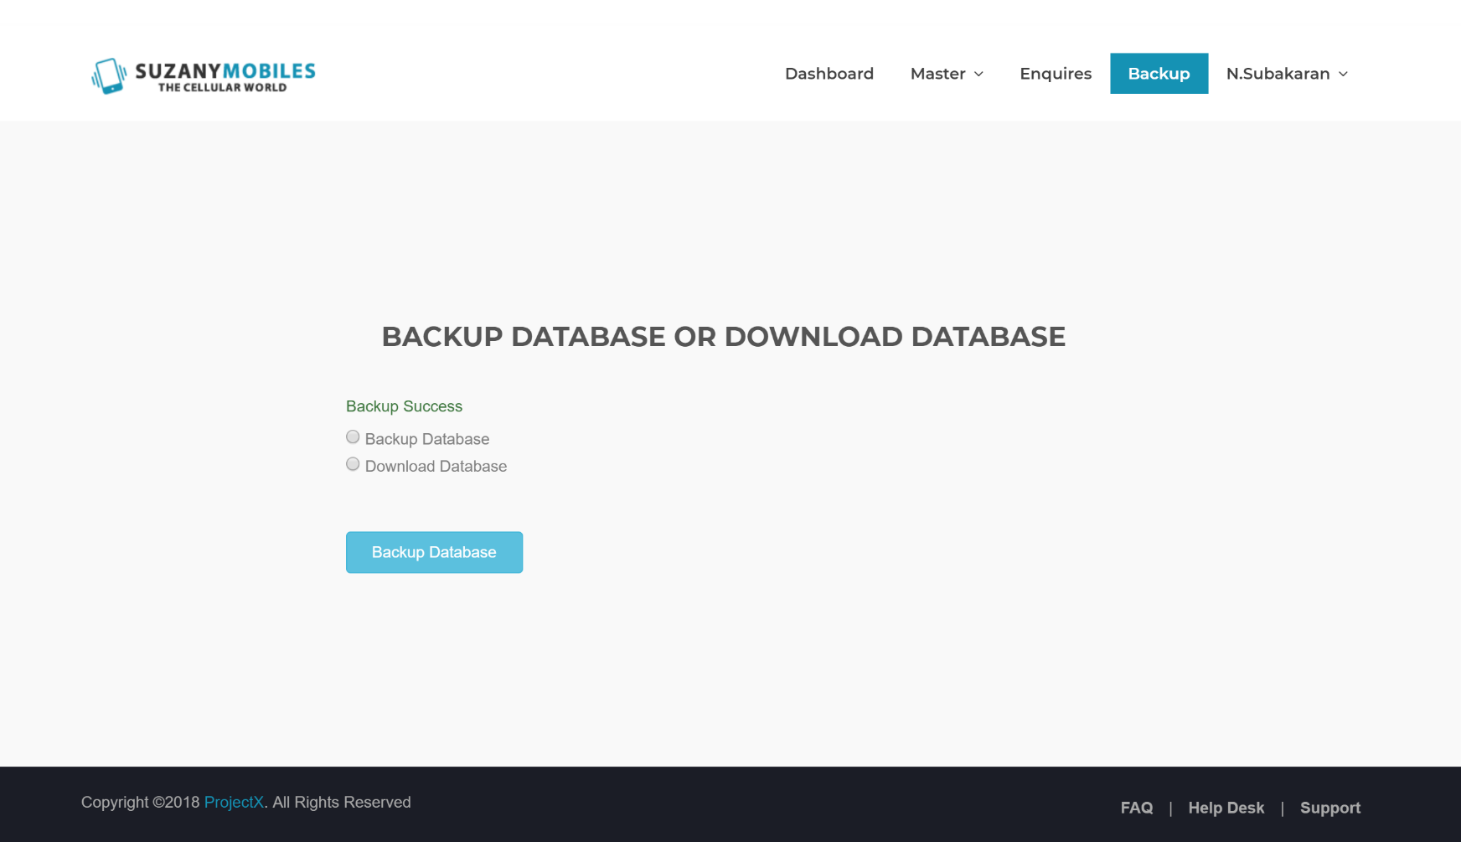

# How to restore backup

Step 1 – Click on the “Restore database” button



Step 2 – Click on the file location and click the “Save” button

